

Interactive Map of SETU Carlow

Design Document

6th December 2024

Supervisor: Dr Oisin Cawley
Student: Gábor Major – C00271548
Table of Contents
Introduction 2
System Architecture 3
Technology Stack 4
Godot 4
Godot Geolocation Library 4
Godot Firebase Library 4
Firebase 4
Structure of stored data 4
Algorithms 7
A* Pathfinding 7
Class Diagram 8
System Sequence Diagrams 9
Navigate To Room 9
View Campus Map 9
Search Room 9
View Room Information 9
Modify Room Information 9
Modify Map Waypoints 9
UI Design 10
Map Overview Screen 10
Search Screen 10
Information Viewing Screen 10
Navigation Screen 10
Admin Room Editing Screen 10
Admin Map Editing Screen 10
References 11

Introduction
The purpose of this document is to outline a design for the Interactive Map of SETU (South East Technological University) Carlow application. It includes the technologies and tools required to create this application and also includes diagrams to show the structure.
A high level overview of the whole system is given, followed by the technologies and libraries used to create the application. A description of the storage structure of data and algorithms used throughout the application are laid out as well.
A class diagram and system sequence diagrams are given according to the specification of the application.
Finally a section of the UI (User Interface) designs are shown as a series of screens that are open on the device during the usage of the application.

System Architecture

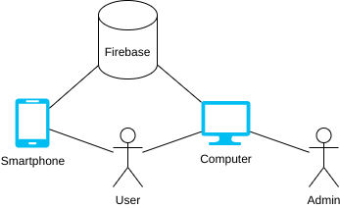

Technology Stack

Godot
The application is written using the Godot game engine. All logic is written so that it can be contained in the application for both the Android operating system and for desktops on the web.
The Android version of the application has only read only access to the database map data, whereas the desktop version will have a login page for the admin user so it would also be able to modify the data.

Godot Geolocation Library
The Android version of the Godot application will get the location of the phone of the user through the Android application programming interface. To do this a plugin called GodotGPSPlugin will be used to connect the map application to the proper geolocation services. The plugin allows for querying for the phone’s latitude, longitude, accuracy, altitude, vertical accuracy, speed, time, and bearing. (PraxisMapper, 2024)

Godot Firebase Library
The Godot application needs a connection to the Firebase database which is facilitated by the GodotFirebase software development kit plugin. It allows for storage of the map data required and for authenticating admin users. (GodotNuts, 2024)

Firebase
Firebase is used to store all of the map data for the application, including the buildings, rooms and various waypoints around the college campus.

Structure of stored data
The Firebase Firestore is a NoSQL database and as such it is not a traditional relational database with tables, it instead has Collections, which store Documents, which store Data, which can be primitive data types such as numbers or words, or links to other Collections of Documents. (Google, 2024)
The structure of the Documents stored in the Firestore is as follows:
- The Base Map Document stores the longitude and latitude, a link to the Collection of Waypoints that are directly on the Base Map, a link to the Collection of Buildings on the Base Map, and two values for when the Waypoints and Buildings in the Collections last got updated.
- The Building Document stores the longitude and latitude of the Building’s main entrance, the name, description and letter of the Building, a link to the Collection of Waypoints directly in the Building, a link to the Collection of Rooms in the Building, and two values for when the Waypoints and Rooms in the Collections last got updated.
- The Room Document stores the longitude and latitude of the Room in the Building, the floor number the Room is on, the parent id of the Building it is in, the name, description and lecturer using the Room, a link to the Collection of Waypoints directly in that Room, and a value for when the Waypoints in the Collection last got updated.
- The Waypoint Document stores the longitude and latitude, the floor number the Waypoint is on, the feature type of the waypoint, which could be that it is a stair or elevator waypoint, the parent id and parent type i.e. Base Map, Building or Room, and the identification numbers of any of the Waypoints it has a connection with.

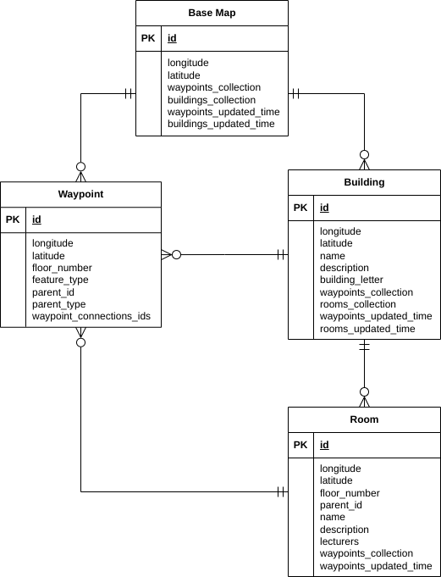

Algorithms

A* Pathfinding
The main algorithm that is going to be used extensively throughout the whole application is the A* Pathfinding algorithm. The costs required for the algorithm are explained as follows:
- F cost is the total estimated cost of the path through this node. This is f = g + h.
- G cost is the cost needed to reach this node.
- H cost is the estimated cost from the node to the end node. This cost is calculated using the Euclidean Distance.
Short pseudocode of the algorithm is given: (Brilliant.org, 2024), (Sebastian Lague, 2014)
- Create a list of unchecked nodes and add the starting node.
- Create an empty list for checked nodes.
- While the unchecked node list is not empty run the following:
  - Set current node to node with lowest f cost from the unchecked list.
  - If current node is destination node then:
    - Signal that the destination has been reached.
  - Else:
    - Remove current node from unchecked list.
    - Add current node to checked list.
    - For each neighbour node of current node run the following:
      - If (neighbour is not in the checked list) and ((neighbour not in unchecked list) or (current node g cost plus cost to neighbour is smaller than neighbour g cost)) then:
        - Set the neighbour’s g cost with newer lower value.
        - Set the neighbour’s from node to the current node.
        - If neighbour not in unchecked list then:
          - Set neighbour h cost.
          - Add neighbour to unchecked list.
- Signal that destination has not been reached.

Class Diagram

System Sequence Diagrams

Navigate To Room

View Campus Map

Search Room
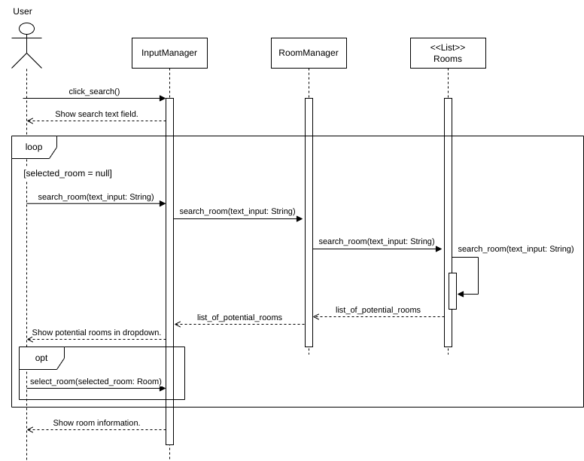

View Room Information

Modify Room Information

Modify Map Waypoints

UI Design

Map Overview Screen

Search Screen

Information Viewing Screen

Navigation Screen

Admin Room Editing Screen

Admin Map Editing Screen

References
PraxisMapper (2024) GodotGPSPlugin. Available at: https://github.com/PraxisMapper/GodotGPSPlugin (Accessed: 19 November 2024)
GodotNuts (2024) GodotFirebase. Available at: https://github.com/GodotNuts/GodotFirebase (Accessed: 19 November 2024)
Google (2024) Cloud Firestore. Available at: https://firebase.google.com/docs/firestore (Accessed: 19 November 2024)
Brilliant.org (2024) A* Search. Available at: https://brilliant.org/wiki/a-star-search/ (Accessed: 24 November 2024)
Sebastian Lague (2014) A* Pathfinding (E01: algorithm explanation). Available at: https://www.youtube.com/watch?v=-L-WgKMFuhE (Accessed: 24 November 2024)

